杭 州 师 范 大 学
2014 年招收攻读硕士研究生入学考试题

考试科目代码： 844
考试科目名称： 英语教学基础知识
说明：考生答题时一律写在答题纸上，否则漏批责任自负。
一、选择题（共10小题，每题2分，共20分）
1. Fluency is achieved largely by ______.
a. pronunciation b. grammatical items c. vocabulary d. chunks
2. The pseudo practice is beneficial only if the pre-service teachers take _______ seriously.
a. rehearsal b. reflection c. inquiry d. comparison
3. Which of the following activities DOES NOT belong to pre-reading activities?
a. prediction b. making inferences c. setting the scene d. skimming
4. The learning activity sculpture body language is designed for developing ________ intelligence.
a. spatial visualizing b. bodily-kinesthetic c. interpersonal d. naturalistic
5. Audiolingual approach is based on ________ view.
a. structural b. functional c. cognitive d. interactional
6. _____ theory considers that language is an intricate rule-based system.
a. Structural b. Functional c. Behaviorist d. Cognitive
7. Efficient classroom management can be achieved by some conditions. One of them is that _____.
- students play appropriate roles
- students’ errors are treated properly
- students can ask questions for teacher’s help
- students can successfully finish task in group work
8. Which of the following actions reflects teacher’s role as a PROMPTER in class?
- Students are taking turns to make sentences. When one makes an error, the teacher asks him to revise.
- T: Have you ever bought clothes with problems?
S: Uhm…
T: For example, a shirt without…
- T: Please produce a conversation.
S: Uhm…
T: (Show a PPT with some language structures.)
- T: Please make a sentence with borrow.
S: I borrowed a paper to write a letter.
T: Well, we don’t say a paper, we say a piece of paper.

9. Which of the following ways of grouping students is more risky?
- Strong students and weak students are grouping separately.
- Grouping students according to seating arrangement.
- Students select their own group members.
- Grouping students by drawing lots.

10. For grammar teaching, grammar should be built on _____ relations between individual lexical items and their subcategories.
a. collocational b. denotative c. connotative d. deductive

二、判断题（共10小题，每题3分，共30分）
- Controlled practice includes: drilling, repetition, substitution, dialogue reading, etc.
- Higher order questions require more reasoning, analysis and evaluation.
- We should require the students to acquire native-like pronunciation.
- Children do not need to learn grammar rules when learning a foreign language.
- English-English explanations are the best way for vocabulary teaching.
- Dictogloss needs 4 stages: presentation, discussion, dictation, reconstruction.
- Both listening and reading teaching need the way of interactive model.
- The difference between mapping and brainstorming is whether students can organize their ideas.
- TBL provides a paradigm for form-focused lessons.
- Chunks can be easily stored in memory, which helps us produce language more fluently.

三、简答题（本题共3小题，共25分）
1. 《英语课程标准》指出：义务教育阶段的英语课程具有工具性人文性性质？如何理解其中的“人文性”？请简答之。（7分）
2. 为什么要把“学习策略”列为英语课程目标之一？请简答之。（8分）
3. Would you please give some tips for MAKING QUESTIONS in class more effective?（10分）
四、论述题（本题共1小题，共15分）
1、Illustrate the application of socio-constructivist theory to language teaching.

五、设计题（本题共3小题，共60分）
（一）就所给材料，设计导入方法，并写出教师的导入语言（共15分）
1. 导入方法（语言不限）（5分）；
2. 教师的导入语言（用英语）（10分）。
（材料来源：PEP三年级上册 Unit 5）
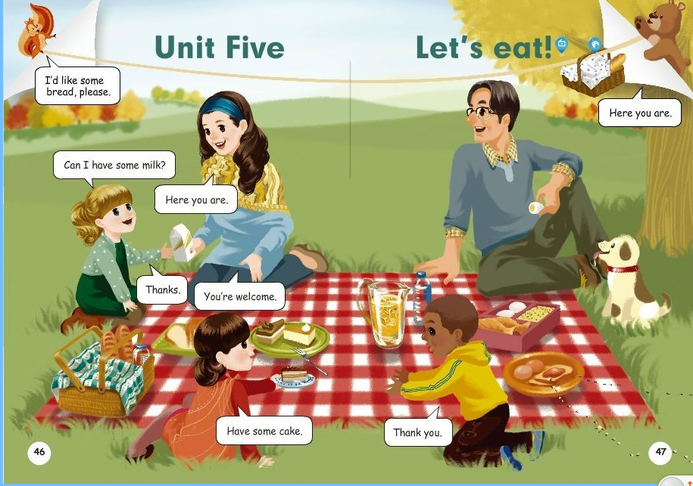

（二）就所给的材料，给出相应设计（共25分）
1、设计一个板书（10分）
2、设计一个课堂交际任务（语言不限）（15分）
需要涉及的内容含：任务名称、任务所需时间、任务目的、任务方式、任务要求、所要提供的材料等。（材料来源：Go for it 七年级上 Unit 6）
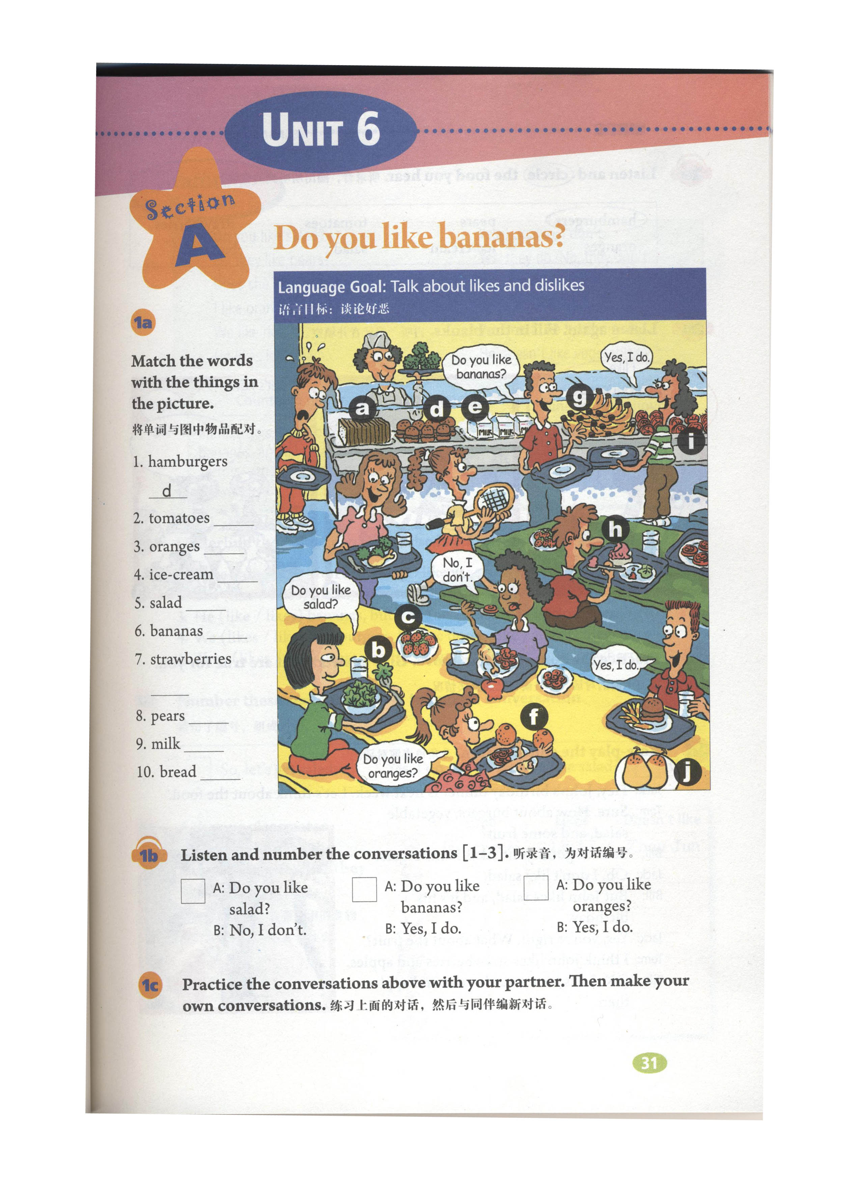

（三）就所给的材料，设计一份教学简案（语言不限）（20分）
（材料来源：人教版高中《英语》必修四，Unit 4 Body Language）
